# **Name: Abdurrahman Qureshi**

# **Roll No: 242466**

Practical No: 9

Q) Write a script using grep command to find the number of words character, words and lines in a file.

CODE:

if [ -z "$1" ]; then

  read -p "Enter the filename: " filename

else

  filename=$1

fi

if [ ! -f "$filename" ]; then

  echo "Error: File '$filename' not found!"

  exit 1

fi

char_count=$(wc -m < "$filename")

word_count=$(wc -w < "$filename")

line_count=$(wc -l < "$filename")

echo "Characters: $char_count"

echo "Words: $word_count"

echo "Lines: $line_count"

OUTPUT:

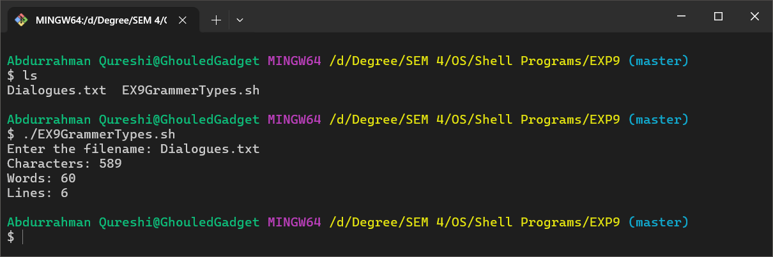

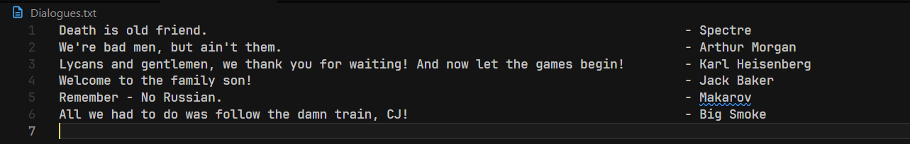

Q) Write a script using egrep command to display list of specific type of files in the directory.

CODE:

echo "Files in the current directory:"

ls -p | grep -v /

echo ""

echo "Files grouped by extension:"

for ext in $(ls -1 | awk -F. 'NF>1 {print $NF}' | sort -u); do

    echo -e "\n* .$ext files:"

    ls *.$ext 2>/dev/null

done

OUTPUT:

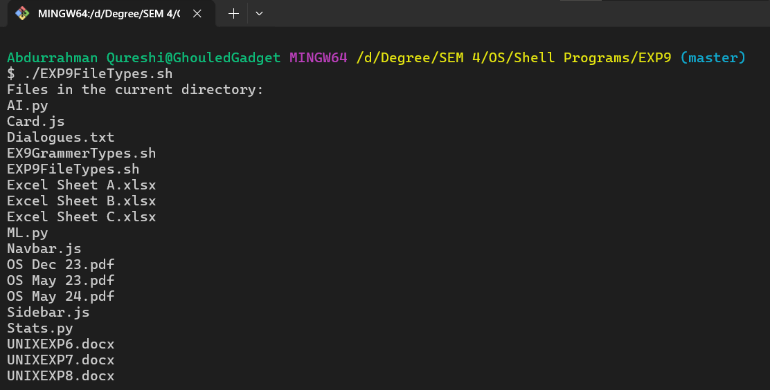

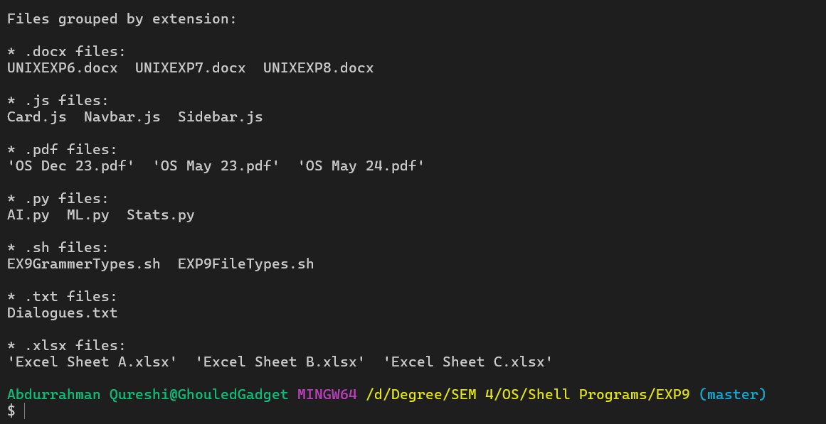

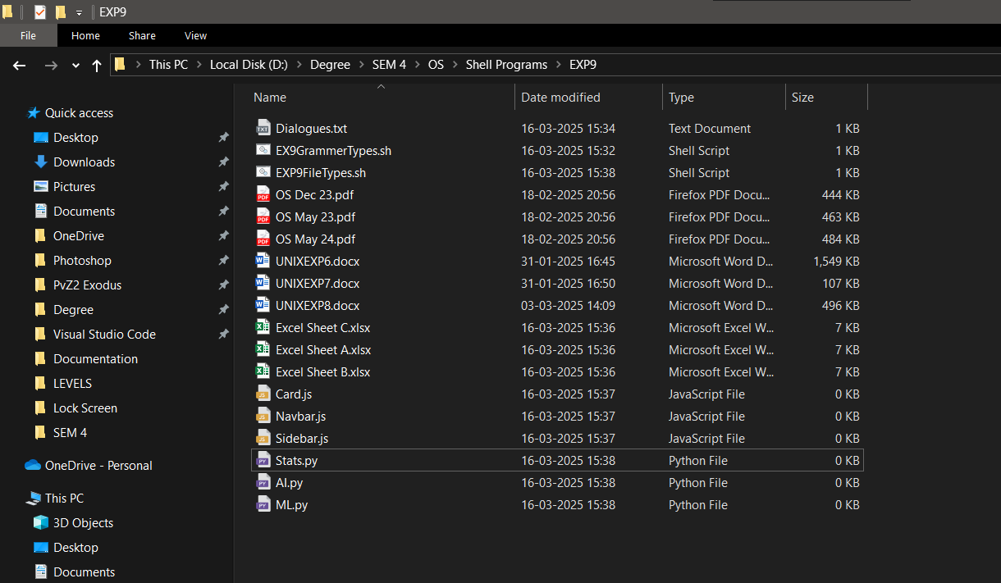

Q) Write a script using sed command to replace all occurrences of particular word in given a file.

CODE:

if [ -z "$1" ]; then

  read -p "Enter the filename: " filename

else

  filename=$1

fi

if [ ! -f "$filename" ]; then

  echo "Error: File '$filename' not found!"

  exit 1

fi

if [ -z "$2" ]; then

  read -p "Enter the word to replace: " old_word

else

  old_word=$2

fi

if [ -z "$3" ]; then

  read -p "Enter the new word: " new_word

else

  new_word=$3

fi

sed -i "s/$old_word/$new_word/g" "$filename"

echo "Replaced all occurrences of '$old_word' with '$new_word' in '$filename'."

OUTPUT:

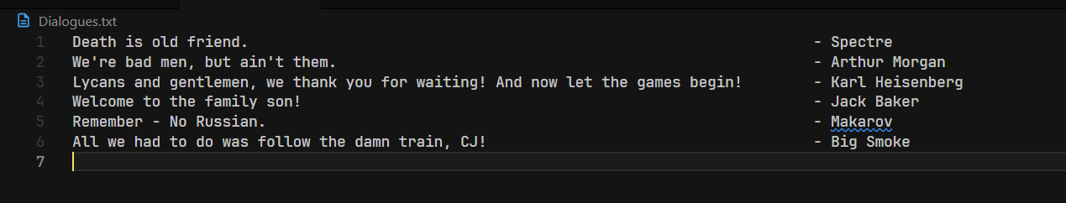

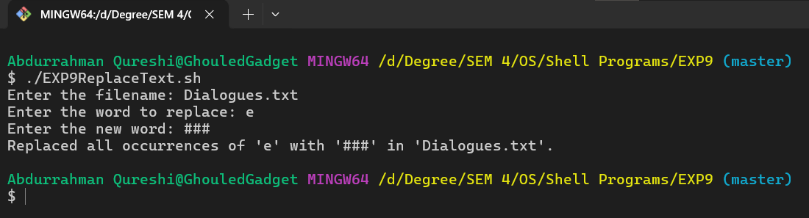

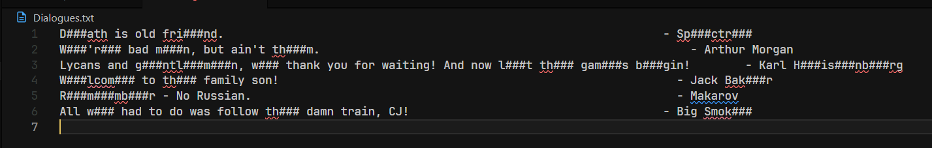

Q) Write a script using sed command to print duplicated lines in input. CODE:

echo "Enter a year:"

read year

if [ $((year % 4)) -eq 0 ] && [ $((year % 100)) -ne 0 ] || [ $((year % 400)) -eq 0 ]; then

    echo "$year is a leap year."

else

    echo "$year is not a leap year."

fi

OUTPUT:

